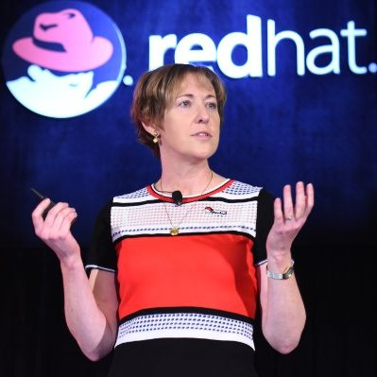

Margaret Dawson – Global Product Marketing at Red Hat

A 20-year tech industry veteran, Margaret is a frequent author and speaker on cloud computing, big data, open source, women in tech, and the intersection of business and technology. She is a proven entrepreneur and intrapreneur, having led successful initiatives and teams at several startups and Fortune 500 companies, including Amazon, Microsoft and HPE. Currently, Margaret leads global product marketing at Red Hat, the world’s leading open source software company. Prior to Red Hat, she was Vice President of Product Marketing and Cloud Evangelist for the cloud computing division of Hewlett-Packard Enterprise. Margaret serves as an advisor to Cloud Connect, the Cloud Network of Women, and Women of the Channel, as well as to many startup CEOs. She recently received a Stevie Award for Mentor and Coach of the Year.

