WEST GARAGE
2400 Children’s Way
Nashville, TN 37212
615-936-1215, option 3
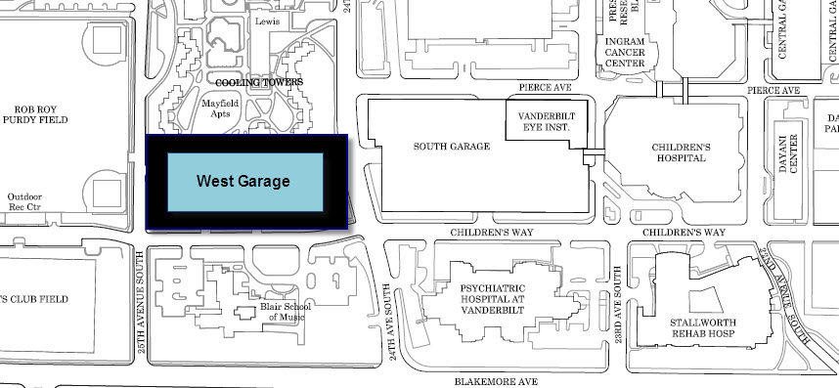

Use the entrance on 25th Avenue and park in any space in the number range 1-227.

