SHAUNDA R. CLINGMAN-AVERY

Bridgestone Americas, Inc
200 4th Avenue S • Nashville, TN 37201
615-937-4476 • averyshaunda@bfusa.com

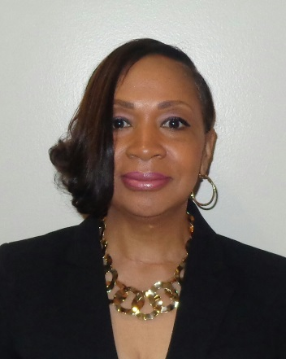
Shaunda Clingman-Avery joined Bridgestone Americas in 2016 as Senior Manager, Business Solution Delivery. In her role, Shaunda is responsible for coaching and leading the Business Solution Delivery team in delivering SAP solutions for strategic IT projects, enhancements and release management for Bridgestone Americas.
Located in Nashville, Shaunda is a senior IT professional with solid and diverse experience in leadership, application development, implementation and project management.

Shaunda came to Bridgestone Americas with 30-plus years of IT experience with a strong background in SAP retail and financials, JDA merchandise management, supply chain and warehouse management, inventory management, logistics/retail and master data management. Shaunda formerly served in leadership roles at Luxottica Retail where she led several areas including Customer Solutions, Business Solutions, and Data Migration. She was on-site leadership for the acquisition of Sunglass Hut and Cole National (Pearle, Sears, and Target Optical). Shaunda was also part of the leadership team for the JDA implementation and SAP Retail implementation for Luxottica as well.
Through her experiences, Shaunda’s leadership success is grounded by eight leadership principles:
- Begin with the end in mind
- Focus on the People
- Get Results
- Quality above ALL else
- Impact the Business
- Do what matters Most
- Overcome Obstacles
- Take Personal Responsibility

Shaunda is a native of Cincinnati, Ohio and is the proud mother of two children, Jordan and Julian. Jordan Avery (25) is a graduate of Tennessee State University with a Bachelor’s Degree in Human Performance Sports Science. Julian Avery (16) is a sophomore at John Overton High School where he attends the Academy of Information Technology and plays football.

