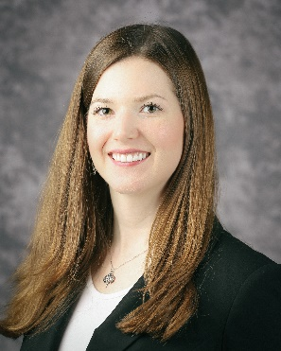

Sarah Kennedy – Security Vulnerability Engineer at HCA
Director of Membership at ISC2 Middle TN

Sarah Kennedy currently works at HCA, Inc. as a Security Vulnerability Engineer. She received her Master’s in Information Security from Lipscomb University and she received her undergraduate degree in Telecommunications Systems Management from Murray State University. In her free time she enjoys SCUBA diving, singing, reading fantasy and SciFi books, playing video games, and traveling.

